Robert Minson

January 19, 2023

SYM-408

Prof. Dilts

Design a Dimensional Schema

ERD of Star Schema

List of the first two tables and their columns on the left & a query 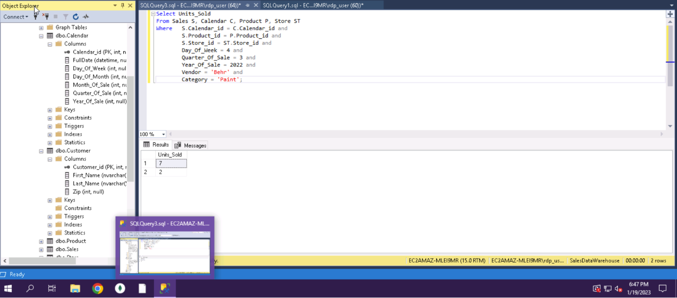

List of the next two tables and their columns on the left & a query 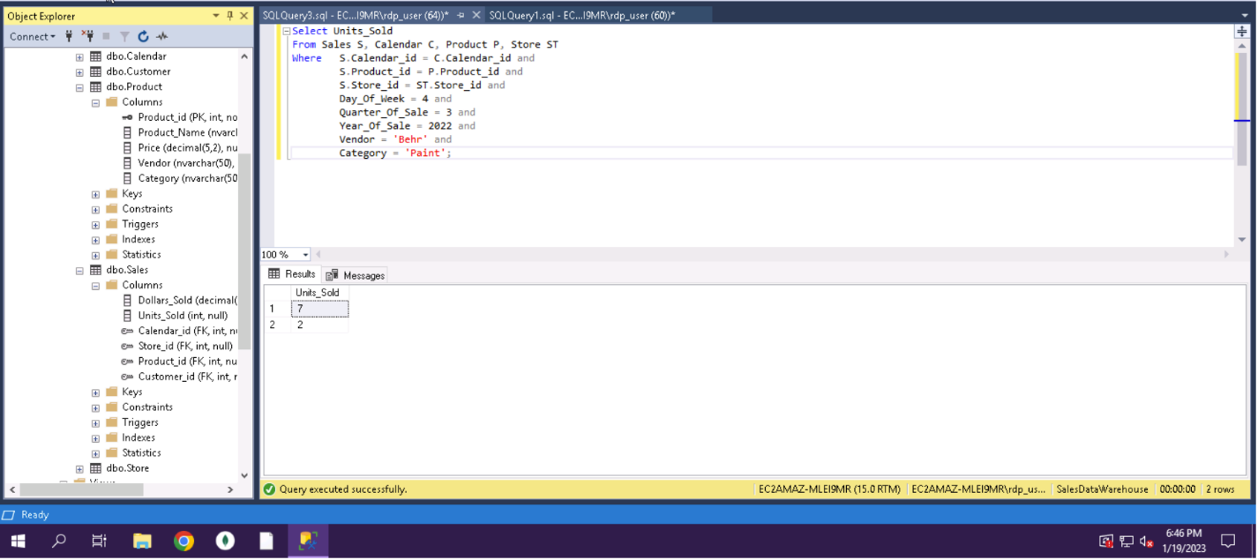

List of the last table and it’s columns on the left & a query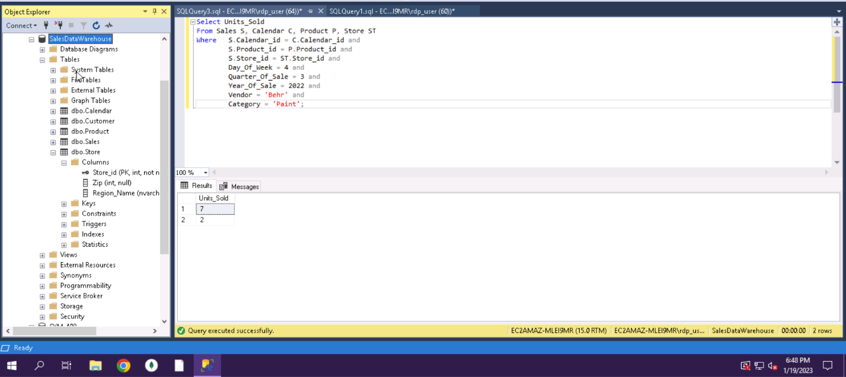

Data within the Calendar table 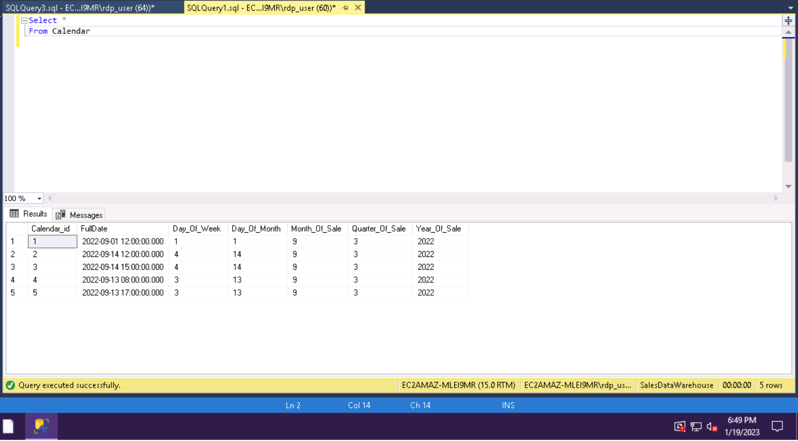

Data within the Store table 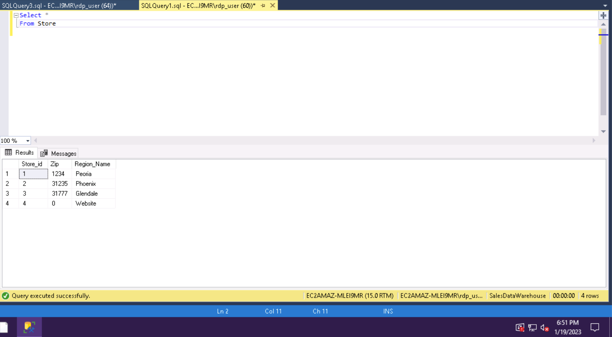

Data within the Product table 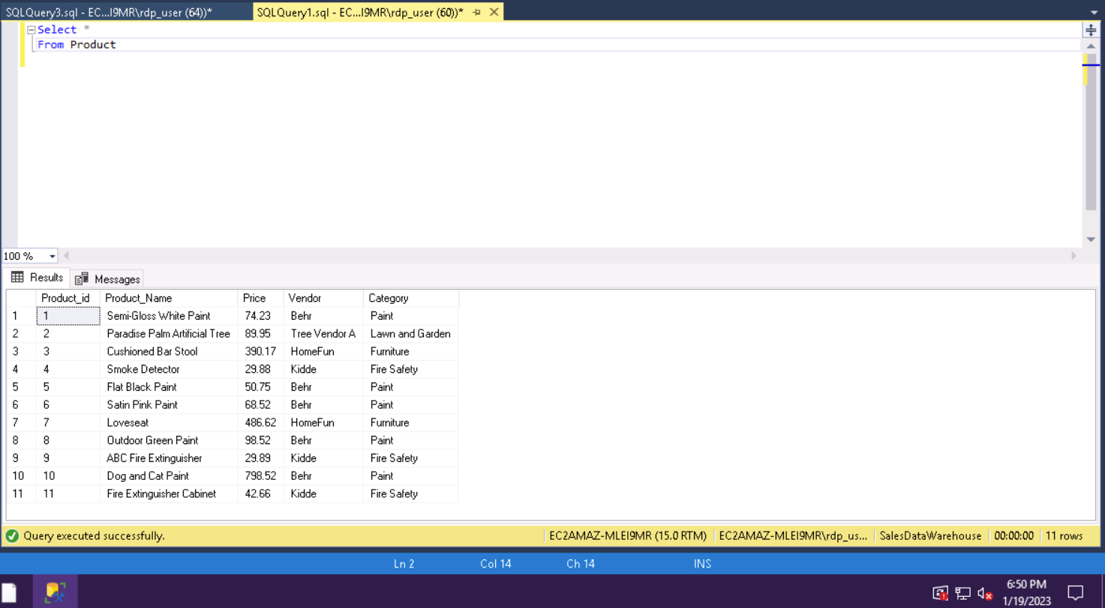

Data within the Customer Table 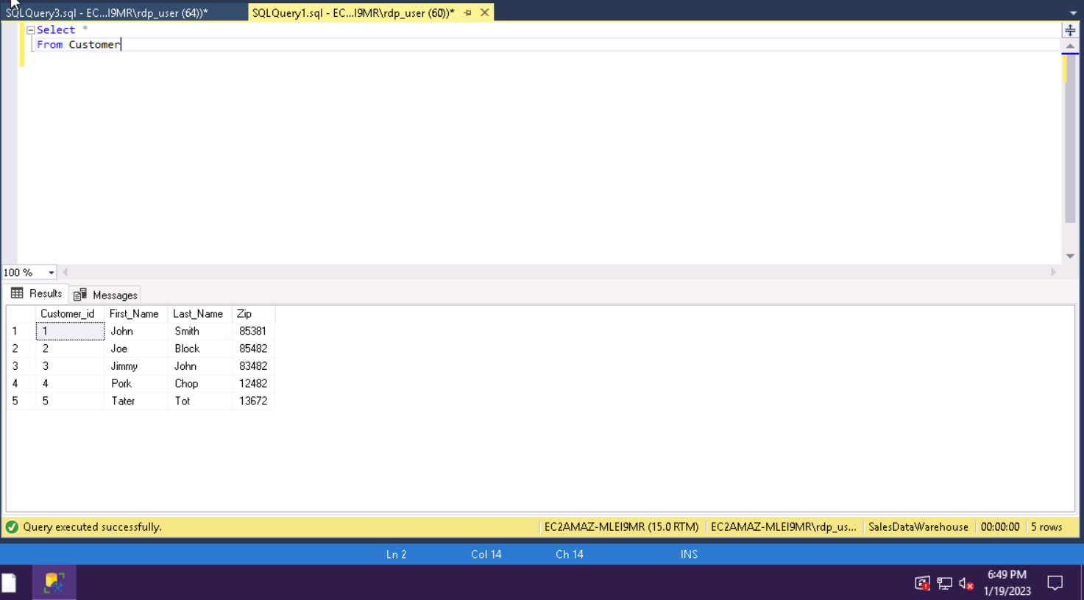

Data within the Sales table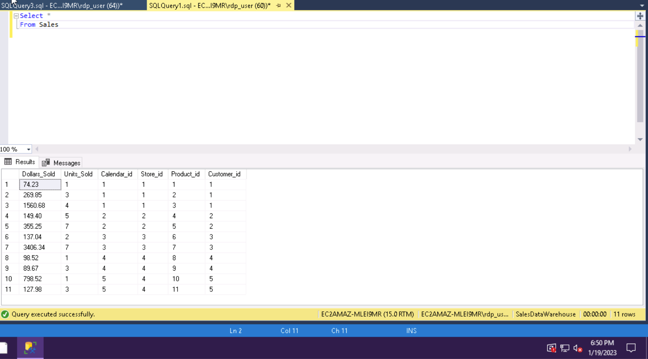

Query showing how many paint cans were sold on a Wednesday from Behr in the Arizona area in the 3rd quarter of 2022 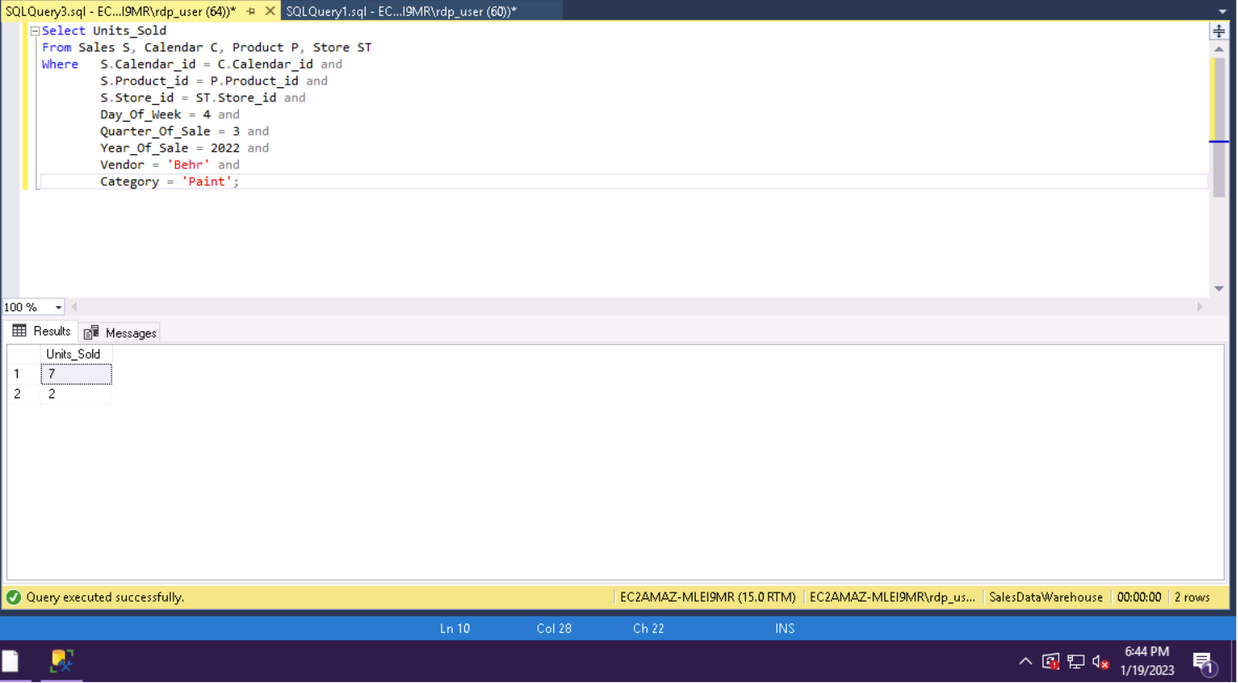

Queries, as shown above, can help executives make decisions when in business-critical situations. This is because it allows them to pinpoint specific data that they are looking for. If they are wanting to learn if on certain days items sale large amounts of units. This would tell them if it would be good to run discounts on slower days to allow more sales of that specific product. Queries like this give specific data to help make both board and specific decisions for the business.